we copy the concept from https://colorlib.com/wp/template/coffee-blend/ ( we follow the concept instead of coffee and black to wedding dress and white)

Those are texting that have to Type

About

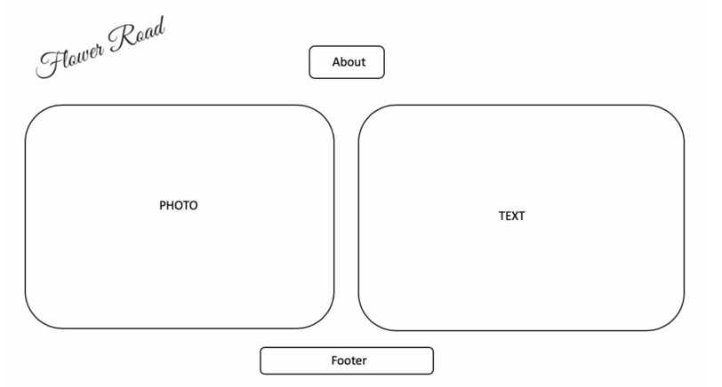

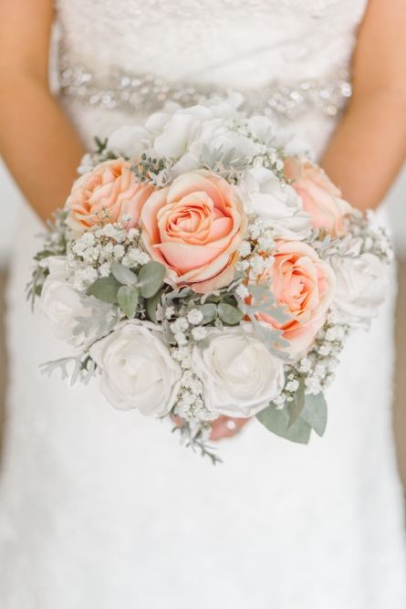

Finding best for your wedding

You can walk a Flower Road with us

( can you put code for can changing font? I will change font )

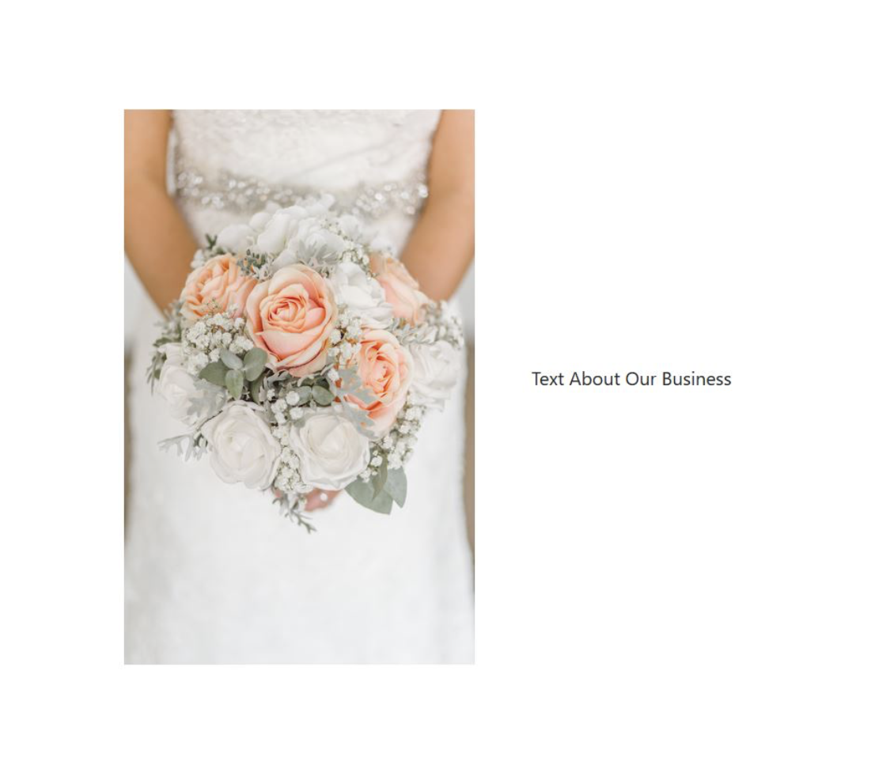

Gallery

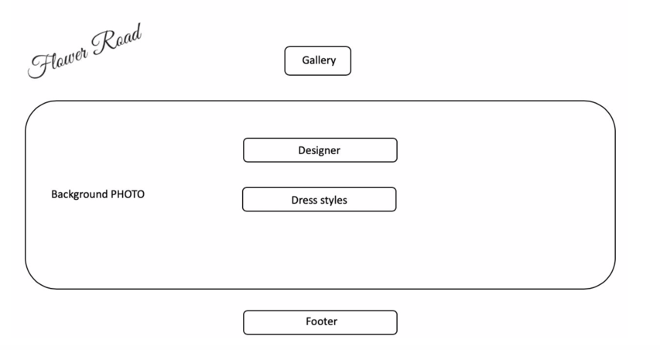

I want to put 2boxes for Designer and Dress style like this below so write Designer instead of Any Style and have lists to click arrow( plz write code for linking to designer when we click the name of designer, is it possible?)

Dress Styles gonna same way of Designer



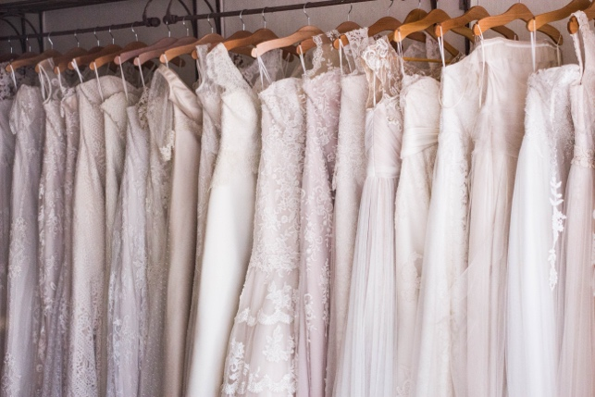

Events



(Thinking 1: put this image middle of the page and write events below the pic

Thinking2: put this left and write events right side(middle)

(I want this font

<link href="https://fonts.googleapis.com/css?family=**Montserrat**" rel="stylesheet">

**Specify in CSS**

Use the following CSS rules to specify these families:

font-family: 'Montserrat', sans-serif;

Wedding Planning

Decorating

And write this end of it with different style

Contact us for event inquiries

Blog

I misunderstood blog when I wrote design.:)

I don’t want to any background photo since posts has picture

(I saved images on images folder)

Can you just put 4pictures with different size?

They have space between pictures☺ I just couldn’t make it

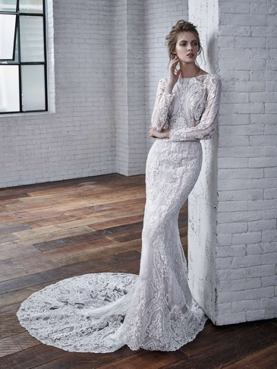

and if we click that have information like below?

If you can’t just make as below like description

Colette



Colette is the ultimate princess dress! This spectacular full-length ball gown features a dreamy tulle skirt and sparkling bodice with intricate Indian beaded embroidery. We adore the plunging V-neckline and low V-back, giving this fairytale gown a contemporary twist.

Cecilia



If you’d prefer a sleek and glamorous look, Cecilia is a must try. This mermaid gowns is made from soft stretch Mikado fabric, hugging the figure beautifully. With a flattering strapless, sweetheart neckline and bow detail at the back, this dress is perfect for creating a red carpet style.

Carina



We love this unusual design. Feminine and romantic, with a fashion-forward edge, Carina features a unique burn-out print organza for a breathtaking bridal style. The low plunging sweetheart neckline and high leg slit adds a sultry touch.

Callista

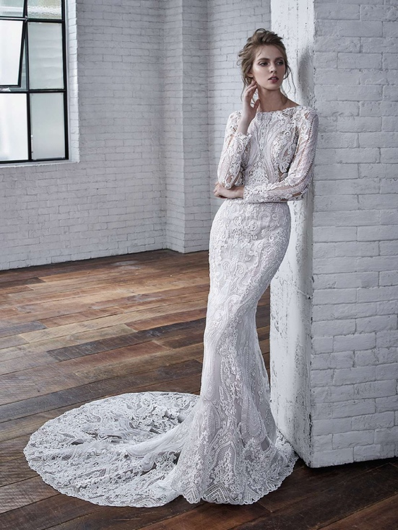

Are sleeves on your bridal wishlist? Callista is ticking all our boxes when it comes to finding a sophisticated style or winter wedding gown. With full-length sleeves and a bateau neckline, this chic gown boasts delicate all-over lace and a gorgeous keyhole back.

( I saw this post on <http://www.findyourdreamdress.co.uk/badgley-mischka-the-chic-2019-collection/>)

Appointment

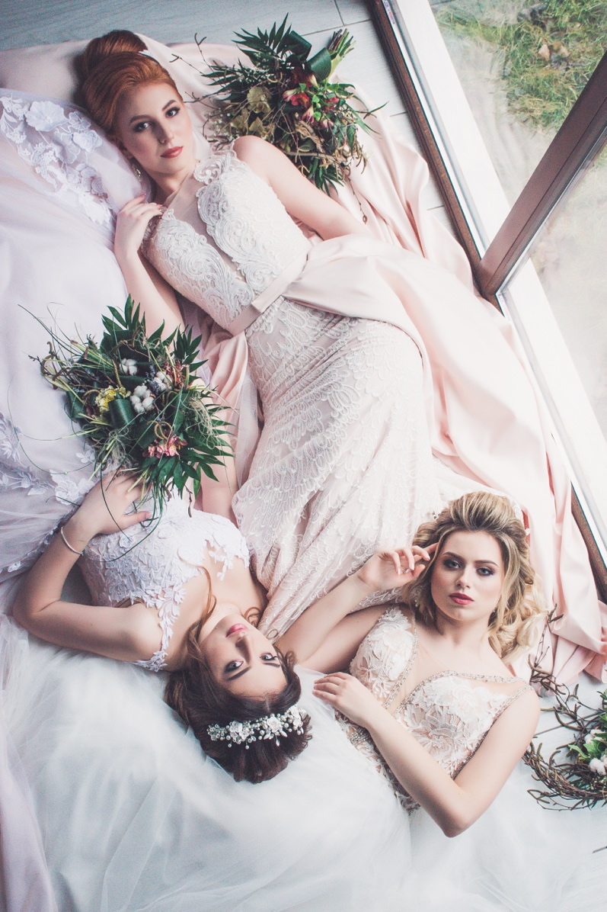

I’m thinking this one middle of top and put those things(get in touch and submit) below that

Or

Put this one left and submit form put right and get in touch text under the middle of them

( same considering like events)

(submit information)

Name

Date

Time

Designer

Phone Number

E-mail

Messages

Submit

Get In Touch

Ang Weddings and Events is based in Manhattan and meetings are by appointment only.  Please contact us through our form here.  We look forward to hearing from you!

